Software Development Lifecycle
Planning > Defining > Design > Building > Testing > Deployment
Software Requirement Specification

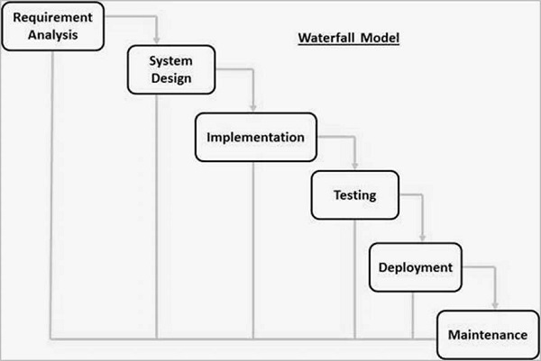
Waterfall model
Linear and sequential types are there.

